
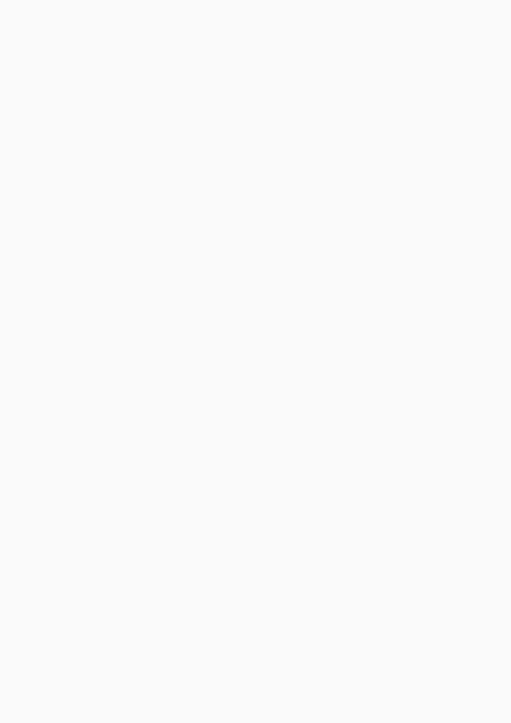

Ahmed Khan Software Engineer
CONTACT | Phone: 03200208597 | Address: Karachi , Sindh.
Email: ahmedarshadkhan567@gmail.com Portfolio: www.reallygreatsite.com
PROJECTS Fuel Guard System | 2026
https://fuel-guard.vercel.app/
Join vehicle owners using smart monitoring to prevent fuel theft and track efficiency.
Secure, precise, and tailored to your fleet.
Library Management System | 2025
A Library Management System is a software project that helps manage books,
members, issuing, returning, and record keeping efficiently in a library.
EDUCATION Mehran University of Engineering and Technology | 2024-
Present
Bachelor in Software Engineering
Hiast College | 2022 - 2024
CERTIFICATES | Geting started with AI on Jetson Nano | Software Architecture
NVIDIA Coursera
Introduction to Networking and Cloud Data Analytics Job Simulation
Computing
Deloitte.
Coursera
Cybersecurity Job Simulation
Newyork Job CEO Council

